ASID Fellow/Honorary Fellow Video Submission Guide
- Include a 3-5 minute video of yourself providing that could include detailed information of the following: (NOTE: The list below is a suggestive narrative only. Be creative and use this time to highlight yourself and complete the story of your nomination package! Your video could also include portfolio images or details of significant work experience.)
- What would it mean for you to become an ASID Fellow? If applicable, in what ways has ASID helped your career and/or developed your skills as a designer/leader/educator within the industry?
- Talk about your engagement with students, emerging professionals and the younger generation of designers overall.
- Share with us other design-related national organizations that you have been actively involved with (WELL, CIDQ, AIA, IIDA, USGBC, NCARB, CIDA, etc.)
- How has your work made an impact on the profession of Interior Design?
  - Discuss your contributions to the Profession and Industry. How have you brought forward thinking, innovative ideas to ASID and/or other organizations?
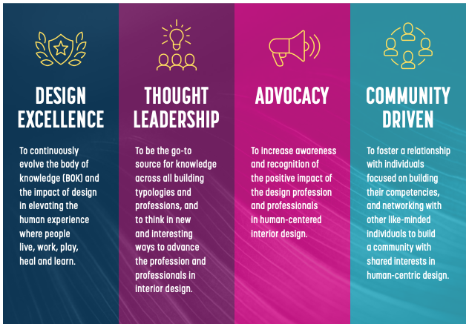
  - Describe opportunities in the work you do, (or have done), that is related to ASID’s strategic plan and its four core values.

